**Hello this is my writeup for the PHP-J4G web challenge from h4k-it.com.**

So we’ve been given the ip address and the port in which we can access the website.

After accessing the website I get a login page that requires a password.

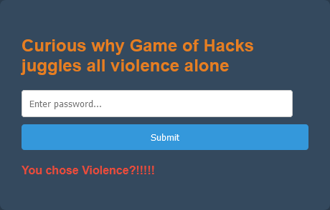

I try random values and default passwords to no success.

I then view the source-code of the website and find some hex values.



I decode the hex value(From Hex) from the cyberchef and I get a php-script.

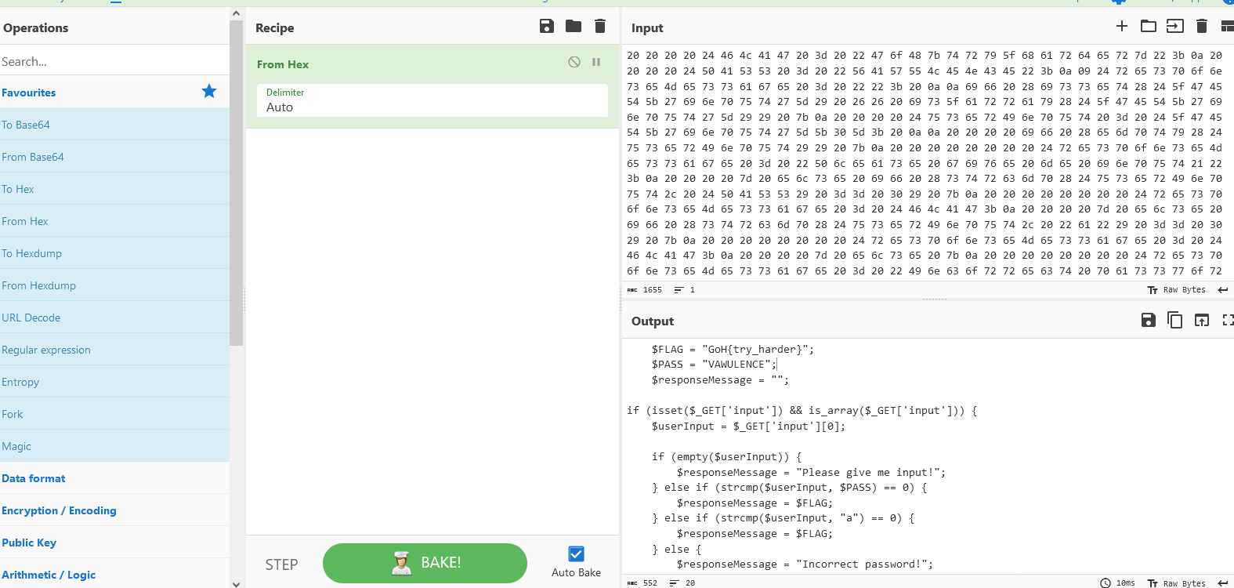

I go through the php-script to look for hints.

I try the **“VAWULENCE”** input they have provided to no sucesss.

Then I try the **“a”** input they have provided the **BOOM!** That’s my flag **[GoH{Wh47_Typ3_w45_th3_1nPu7_Ag41n?}]**

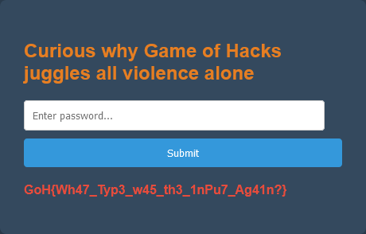

Thank You.

**@Duncan.**